Poster with Horizontal Layout: Title of Poster in Calibri, Boldface, 60 Points

Sponsor Logo



Names of Authors in Calibri, 36 Points, Boldface

Department in 32 points bold Institution in 32 points bold

Institution Logo

# Heading (Calibri: 44 Points, Bold)

The first section of the poster should define the topic and show its importance. A good test is whether the poster can orient the audience to these two aspects in 20 seconds. Shown in Figure 1 is a possible layout for a poster. Note that this poster uses sentences for the headings. These sentences tell the story of the poster. If using sentences for the headings, you will want to reduce the type size of the heading. This section was set in Calibri, boldface, 36 points.

# Heading (Calibri: 44 Points, Bold)

At least one section of the poster should present results. An important point with posters is to rely on visuals rather than longs blocks of text to communicate. Figure 3 shows another possible layout for posters. This section was set in Calibri, boldface, 36 points.



Figure 3. Another example poster with caption at 36 points [3].

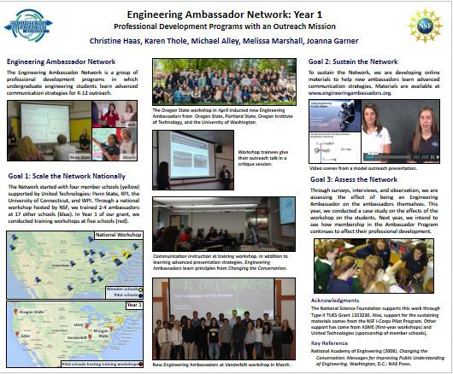

Figure 1. Example poster with caption at 36 points [1].

# Heading (Calibri: 44 Points, Bold)

The second section of the poster might serve a number of purposes: background, methods, or system design. An important point with posters is to rely on visuals rather than longs blocks of text to communicate. Figure 2 shows another possible layout for a poster. Notice how the middle column is used for illustrations. Also, note how the top illustrations serve to orient the reader to the title. This section was set in Calibri, boldface, 40 points.

Figure 2. Another example poster with caption at 36 points [2].

# Heading (Calibri: 44 Points, Bold)

At least one section of the poster should present results. An important point with posters is to rely on visuals rather than longs blocks of text to communicate. Figure 3 shows another possible layout for posters. This section was set in Calibri, boldface, 36 points.

# Heading (Calibri 44 Points)

The final section of the poster generally provides conclusions and recommendations. This section was set in Calibri, boldface, 36 points. As with the first section, this section is read by most passers-by.

Acknowledgments (Calibri, 32 points)

In this template, acknowledgments are set in Calibri, 28 points. Try to keep the acknowledgments to one or two lines.

References (Calibri, 32 points)

1. **Couch, Eric, Jesse Christophel, Eric Hohlfeld, and Karen Thole, "Cooling Effects of Dirst Purge Holes on the Tips of Gas Turbine Blades" (Blacksburg, VA: Virginia Tech, April 2003).**
2. **Christine Haas, “Engineering Ambassador Network: Year 1,” *2015 ASEE Conference***

(Seattle, WA: ASEE).

1. **Jeffrey W. Kaeli, Hanumant Singh, and Roy Armstrong, "Morphological Image Recognition of Deep Water Reef Corals" (Blacksburg, VA: Virginia Tech, October 2005).**